OilPaint – Image Effects
'Oil Paint - Image effect' is a post-processing effect for Unity3D that can give your games the look of an oil painting. It is based on Anisotropic Kuwahara filter. (demo #1, demo #2).

Add the effect.
Add 'Oil Paint - Image Effect' is easy. Select the camera you're going to use (usually called 'Main Camera') in the 'Hierarchy' editor window, then click on 'Add Component' button in the 'Inspector' window.

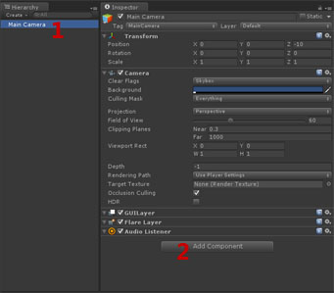
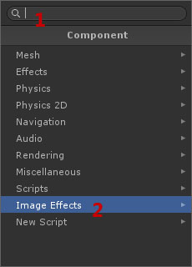

Now you can select the effect in two different ways. The first way is using the search field and write 'Oil Paint', then select the effect.
The second way is select the category 'Image Effects', and finally 'Oil Paint'.

Setting the effect.
'Oil Paint - Image Effect' is also very easy to adjust. Simply select the strength you want in 'Oil Paint mode'. Higher modes are more costly to the GPU.

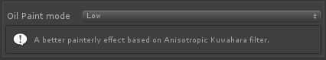
You can also select 'Custom' mode and define yourself the strength of the effect.

Frequently asked questions.

- Can I use the free version (Personal Edition) of Unity3D?
YES, since the version 5 of Unity, this package works both free and pro version.

- What version of Unity should I need?
You need the version 5 or higher.

- Does it need any special hardware?
'Oil Paint - Image Effect' needs a GPU that supports Shader Model 4.0 or higher. At desktop PCs, any card compatible with DirectX 10.0 are supported (ATI Radeon HD2000 or higher, Nvidia GeForce 8 (8xxx) Series or higher or Intel GMA 4500 or higher).

In generall, any device with a decent GPU after the 2009 should work.

Mobile platforms are not supported at the moment.

- What about performance?
On a Intel i5 PC with GTX550 GPU, these demo at 1280x720, takes 0.3ms, 0.9ms and 1.9ms depending on the selected mode.

- Works with HDR? and with DirectX 11? Deferred Lighting?
Yes, yes and yes.

- Includes source code?
Yes, all source code is included (also shaders).

